Computer Architecture
Homework 6
Theme: Internal Memory
All questions are weighted equally. Show your work to receive credit.

- Consider a dynamic RAM that must be given a refresh cycle 66 times per millisecond. Each refresh operation requires 150 ns; a memory cycle requires 250 ns.

  - What percentage of the memory’s total operating time must be given to refreshes?
Given,
DRAM refresh cycle duration is 150nsec.
DRAM is refreshed 66 times per msec.
Hence, the time spent for memory refreshes per millisecond is 66 * 150 nsec.
Percentage of time spent on memory refreshes = 66*150nsec/1msec*100 = 66*150*10⁻⁹*100/10⁻³ = 66*15*10⁻³ = 0.99%

  - What is the maximum number of memory cycles in 1ms that can be used for reads/writes (refresh cycles are not part of memory accesses)?

From above, 0.99% of the time is spent on memory refresh. This implies 99.01% of the time is available for memory access i.e. read/write operations.

Hence, per 1 msec, the maximum time available for memory read/write operations is 99.01/100*1msec = 99.01*10⁶/100 nsec = 990100 nsec

Given,
Memory cycle duration is 250 nsec.
Considering each memory operation can be completed in one memory cycle, the maximum number of memory read/write operations that can be performed in 1 msec duration are 990100 / 250 = 3960

- Draw the diagram of a typical 16 Mb DRAM (4M X 4) and explain its action.

Dynamic RAM (DRAM) is made with cells that store data as charge on capacitors. Because capacitors have a natural tendency to discharge, DRAMs require periodic charge refreshing to maintain data storage.
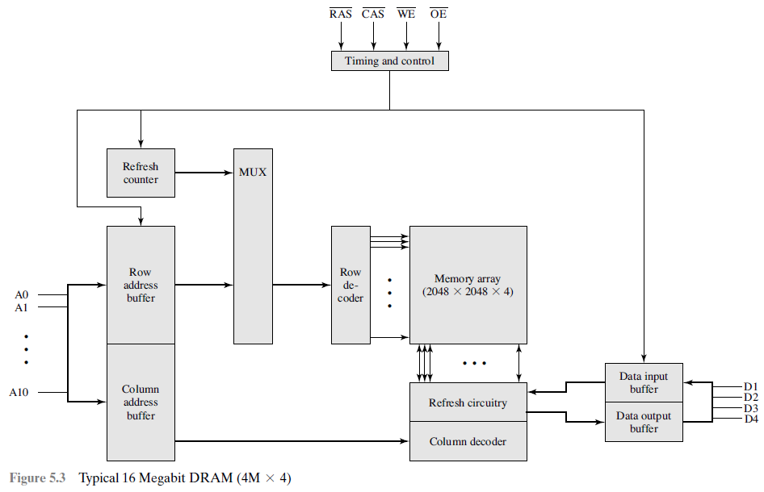

Shown in figure above is a typical organization of a 16-Mbit DRAM where 4 bits are read/written at a time. Logically, the memory array is organized as four square arrays of 2048 X 2048 elements, which are connected by both horizontal (row) and vertical (column) lines. Each horizontal line connects to the Select terminal of each cell in its row; each vertical line connects to the Data-In/Sense terminal of each cell in its column. Address lines supply the address of the word to be selected. Here, 11 address lines are needed to select one of 2048 rows. The action is performed using a row decoder. An additional 11 address lines select one of 2048 columns of 4 bits per column. The 22 required address lines for a 2048 X 2048 array are passed through select logic external to the chip and multiplexed onto the 11 address lines. First, 11 address signals are passed to the chip to define the row address of the array, and then the other 11 address signals are presented for the column address. These signals are accompanied by row address select (RAS) and column address select (CAS) signals to provide timing to the chip.

Four data lines are used for the input and output of 4 bits to and from a data buffer. The write enable (WE) and output enable (OE) pins determine whether a write or read operation is performed.

On input (write), the bit driver of each bit line is activated for a 1 or 0 according to the value of the corresponding data line. On output (read), the value of each bit line is passed through a sense amplifier and presented to the data lines. The row line selects which row of cells is used for reading or writing.

Because only 4 bits are read/written to this DRAM, there must be multiple DRAMs connected to the memory controller to read/write a word of data to the bus.

The figure includes refresh circuitry. All DRAMs require a refresh operation. A simple technique for refreshing is, in effect, to disable the DRAM chip while all data cells are refreshed. The refresh counter steps through all of the row values. For each row, the output lines from the refresh counter are supplied to the row decoder and the RAS line is activated. The data are read out and written back into the same location. This causes each cell in the row to be refreshed.

- Draw the diagram of an SRAM cell and explain its action.

Static RAM (SRAM) is a digital device and stores binary values using flip-flop logic-gate configurations. SRAM holds data as long as power is supplied to it and does not need refresh circuitry.
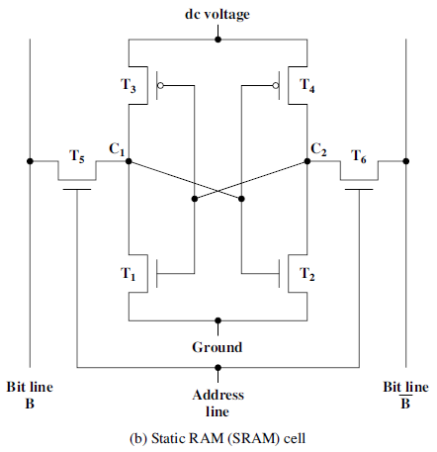
The figure above shows a typical SRAM structure for an individual cell. Four transistors (T1, T2, T3, T4) are cross connected in an arrangement that produces a stable logic state.

In logic state 1, point C1 is high and point C2 is low; in this state, T1 and T4 are off and T2 and T3 are on.1 In logic state 0, point C1 is low and point C2 is high; in this state, T1 and T4 are on and T2 and T3 are off. Both states are stable as long as the direct current (DC) voltage is applied.

SRAM address line is used to control two transistors (T5 and T6). When a signal is applied to this line, the two transistors are switched on, allowing a read or write operation. For a write operation, the desired bit value is applied to line B, while its complement is applied to line B-bar. This forces the four transistors (T1, T2, T3, T4) into the proper state. For a read operation, the bit value is read from line B.

- What are the differences among EPROM, EEPROM? What is a DDR SDRAM?

Differences among EPROM and EEPROM:
Read-Only Memory (ROM) contains a permanent pattern of data that cannot be changed. A ROM is nonvolatile, i.e. no power source is required to maintain the bit values in memory.

A variation on read-only memory is the read-mostly memory, which is useful for applications in which read operations are far more frequent than write operations but for which nonvolatile storage is required. There are three common forms of read-mostly memory: EPROM, EEPROM, and flash memory.

Optically Erasable Programmable Read-Only Memory (EPROM) is read and written electrically. However, before a write operation, all the storage cells must be erased to the same initial state by exposure of the packaged chip to ultraviolet radiation. This erasure process can be performed repeatedly; each erasure can take as much as 20 minutes to perform. Thus, the EPROM can be altered multiple times and holds its data virtually indefinitely.

Electrically Erasable Programmable Read-Only Memory (EEPROM) is a read-mostly memory that can be written into at any time without erasing prior contents; only the byte or bytes addressed are updated. The write operation takes considerably longer than the read operation, on the order of several hundred microseconds per byte. EEPROM combines the advantage of non-volatility with the flexibility of being updatable-in-place, using ordinary bus control, address, and data lines. EEPROM is more expensive than EPROM and also is less dense, supporting fewer bits per chip.

DDR SDRAM:
Synchronous DRAM (SDRAM) exchanges data with the processor synchronized to an external clock signal and running at the full speed of the processor/memory bus without imposing wait states.

With synchronous access, SDRAM moves data in and out under control of the system clock. The processor or other master issues the instruction and address information, which is latched by SDRAM. SDRAM then responds after a set number of clock cycles. Meanwhile, the master can safely do other tasks while SDRAM is processing the request.

A new version of SDRAM, referred to as Double-Data-Rate SDRAM (DDR-SDRAM) can send data twice per clock cycle, once on the rising edge of the clock pulse and once on the falling edge.

There have been two generations of improvement to the DDR technology. DDR2 increases the data transfer rate by increasing the operational frequency of the RAM chip and by increasing the prefetch buffer from 2 bits to 4 bits per chip. The prefetch buffer is a memory cache located on the RAM chip, which enables the RAM chip to preposition bits to be placed on the data base as rapidly as possible. DDR3, increases the prefetch buffer size to 8 bits.

Theoretically, a DDR module can transfer data at a clock rate in the range of 200 to 600 MHz; a DDR2 module transfers at a clock rate of 400 to 1066 MHz; and a DDR3 module transfers at a clock rate of 800 to 1600 MHz. In practice, somewhat smaller rates are achieved.

- How does an SDRAM differ from a DRAM? What is burst mode?

SDRAM-DRAM differences:
SDRAM is Synchronous DRAM. Traditional DRAM is asynchronous.

In a typical DRAM, the processor presents addresses and control levels to the memory, indicating that a set of data at a particular location in memory should be either read from or written into the DRAM. After a delay, the access time, the DRAM either writes or reads the data. During the access-time delay, the DRAM performs various internal functions, such as activating the high capacitance of the row and column lines, sensing the data, and routing the data out through the output buffers. The processor must simply wait through this delay, slowing system performance.

SDRAM exchanges data with the processor synchronized to an external clock signal and running at the full speed of the processor/memory bus without imposing wait states. With synchronous access, SDRAM moves data in and out under control of the system clock. The processor or other master issues the instruction and address information, which is latched by SDRAM. SDRAM then responds after a set number of clock cycles. Meanwhile, the master can safely do other tasks while SDRAM is processing the request.

Burst mode:
SDRAM employs a burst mode to eliminate the address setup time and row and column line pre-charge time after the first access. In burst mode, a series of data bits can be clocked out rapidly after the first bit has been accessed. This mode is useful when all the bits to be accessed are in sequence and in the same row of the array as the initial access.

- What is a parity bit? What is Hamming code? Give examples.

Parity bit:
A parity bit, or check bit is a bit added to the end of a string of binary code that indicates whether the number of bits in the string with the value one is even or odd. Parity bits are used as the simplest form of error detecting code.

There are two variants of parity bits: even parity bit and odd parity bit.
- In the case of even parity, the number of bits whose value is 1 in a given set are counted. If that total is odd, the parity bit value is set to 1, making the total count of 1's in the set an even number. If the count of ones in a given set of bits is already even, the parity bit's value remains 0.
- In the case of odd parity, the situation is reversed. Instead, if the sum of bits with a value of 1 is odd, the parity bit's value is set to zero. And if the sum of bits with a value of 1 is even, the parity bit value is set to 1, making the total count of 1's in the set an odd number.

Hamming code:
Hamming code is an error detecting and error correcting code. Hamming codes can detect up to two-bit errors or correct one-bit errors.
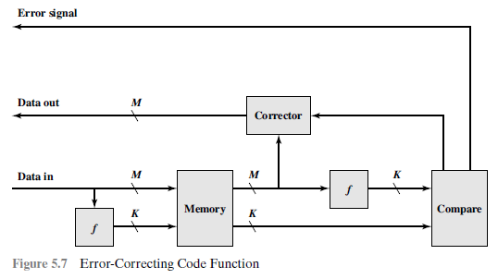
When data are to be written into memory, a calculation, depicted as a function f in figure above, is performed on the data to produce a code. Both the code and the data are stored. Thus, if an M-bit word of data is to be stored and the code is of length K bits, then the actual size of the stored word is M+K bits.
When the previously stored word is read out, the code is used to detect and possibly correct errors. A new set of K code bits is generated from the M data bits and compared with the fetched code bits. The comparison yields one of three results:
- No errors are detected. The fetched data bits are sent out.
- An error is detected, and it is possible to correct the error. The data bits plus error correction bits are fed into a corrector, which produces a corrected set of M bits to be sent out.
- An error is detected, but it is not possible to correct it. This condition is reported.

Due to the limited redundancy that Hamming codes add to the data, they can only detect and correct errors when the error rate is low. This is the case in computer memory (ECC memory), where bit errors are extremely rare and Hamming codes are widely used. In this context, an extended Hamming code having one extra parity bit is often used. Extended Hamming codes allow to distinguish between when at most one bit error occurred and when two bit errors occurred. In this sense, extended Hamming codes are single-error correcting and double-error detecting, abbreviated as SEC-DED.

- What do you understand by interleaved memory?

Main memory is composed of a collection of DRAM memory chips. A number of chips can be grouped together to form a memory bank. It is possible to organize the memory banks in a way known as interleaved memory. Each bank is independently able to service a memory read or write request, so that a system with K banks can service K requests simultaneously, increasing memory read or write rates by a factor of K. If consecutive words of memory are stored in different banks, then the transfer of a block of memory is speeded up.

The interleaved memory system is most effective when the number of memory banks is equal to or an integer multiple of the number of words in a cache line.

Shown in the picture below is an example for 2-way interleaved memory organization and accesses to memory blocks over a period of time.
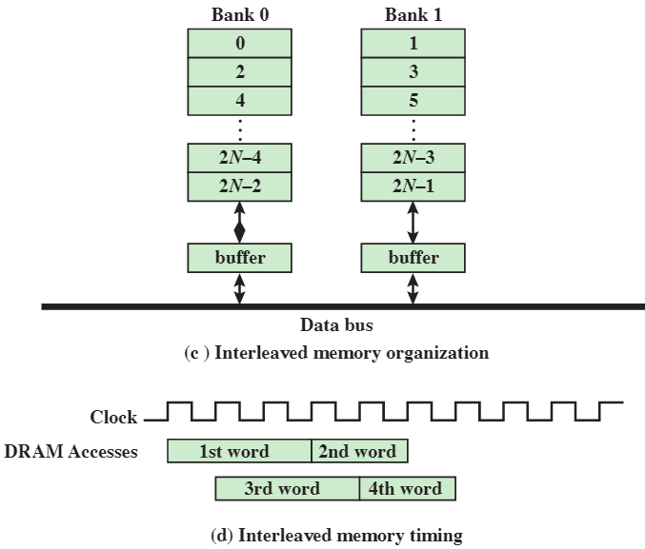

- How do the following work: flash memory, STT-RAM, PCRAM, ReRAM?

Flash memory is a type of semiconductor memory. It is intermediate between EPROM and EEPROM in both cost and functionality. Like EEPROM, flash memory uses an electrical erasing technology. An entire flash memory can be erased in one or a few seconds, which is much faster than EPROM. In addition, it is possible to erase just blocks of memory rather than an entire chip. Flash memory gets its name because the microchip is organized so that a section of memory cells are erased in a single action or “flash.” However, flash memory does not provide byte-level erasure. Like EPROM, flash memory uses only one transistor per bit, and so achieves the high density (compared with EEPROM) of EPROM.

Conventional memory technologies, for e.g. DRAM and NAND flash, exploit the capacitance from electrical charge stored in the memory cell. They have the restriction on storage density scaling with reduced cell area. To overcome this limitation, new resistance-based memory technologies, for e.g. phase-change RAM (PRAM), magnetic RAM (MRAM), or resistive RAM (ReRAM), are being developed. In comparison with conventional capacitance-based memory technologies, these nonvolatile memory technologies are faster and can more easily accommodate scaling to sub-20-nm nodes.

Resistive RAM (ReRAM):

ReRAM operation is mainly field-induced ion migration and hence has a relatively slow speed and limited endurance, relatively good data retention and a simple cell structure that is easy to manufacture. The potentially low cost to fabricate ReRAM makes it attractive for large scale integration. 3D ReRAM architecture is developed which provides higher bit density than planar structures.

Though ReRAM has reliability advantages, low operation voltage, and random access, its power consumption is higher because it has fewer parallel working cells. In addition, for ReRAM to be a major memory product, researchers must find a way to better control its stochastic nature and variability. ReRAM’s production cost and reliability are critical factors towards its adoption in the memory market.

Phase-Change RAM (PRAM):

PRAM is recommended for standard interface or storage memory applications because of its non-volatility, relatively fast operational speed, and scalability.

PRAM basically applies two phases of chalcogenide materials: the amorphous phase with high resistance and the crystal phase with low resistance. Controlling the write voltage and time can reversibly transform the written data from amorphous phase to the crystalline phase. The read data is the result of sensing the resistance difference between the two phases.

Using advanced cell technologies, full integration scheme is developed for 20-nm technology node. Retention tests for 20-nm cell array showed the feasibility of maintaining stored data for 10 years at 85°C. But, thermal disturbance will be a critical factor in developing a PRAM cell. The joule heating in narrow adjacent cells will require a cell structure with a special thermal-blocking scheme or doped phase-change materials that are extremely thermally stable.

STT-MRAM:

MRAM uses tunneling resistance that depends on the relative magnetization directions of ferromagnetic electrodes.6-8 It is an attractive memory option because of its superior scalability, speed, and power consumption. Depending on the writing technique, MRAM is classified as either field switching or spin-transfer torque (STT) MRAM, the latter type being of more interest because of its simple structure and excellent scalability.

Two factors decide how far MRAM can shrink: the critical current density, which is the current density for magnetic switching and the thermal stability factor, which is closely correlated with retention. Critical current density should be as low as possible to fully exploit MRAM’s low power consumption and high density advantages. In contrast, the thermal stability factor should be as high as possible to guarantee reliable device functionality. Adjusting process parameters requires a tradeoff between the two.

Several challenges remain for sub-20-nm MTJ cells and need further development effort on optimizing the ferromagnetic electrode’s composition, upgrading the MTJ stack scheme, and developing advanced MTJ patterning technology.

